Instruction Manual
Bladeless Fan
Model: HBFW

READ AND SAVE THESE INSTRUCTIONS

Please read and follow the instructions in this user manual even if you feel you are familiar with the product, and find a place to keep it handy for future reference.
For your convenience record the complete model number (located on the product identification plate) and the date you received the product, together with your purchase receipt and attach to the warranty and service information. Retain if warranty service is required.
NOTE: The rating of this product (as marked on the product identification plate) is based on specific loading tests. Normal use or the use of other recommended attachments may draw significantly less power.

IMPORTANT SAFEGUARDS
When using any electrically powered product, basic safety precautions should always be followed, including the following:

PLEASE READ ALL INSTRUCTIONS CAREFULLY BEFORE USING THIS PRODUCT

WARNING!: - to reduce the risk of fire, electrical shock or injury to persons or property:

SAFETY INSTRUCTIONS
Important!
- Carefully read the instructions before operating the unit
- This appliance is for indoor use only.
- Rating: This unit must be only connected to a 220-240 V / 50 Hz earthed outlet.
- Installation must be in accordance with regulations of the country where the unit is used.
- If you are in any doubt about the suitability of your electrical supply have it checked and, if necessary, modified by a qualified electrician.
- This fan has been tested and is safe to use. However, as with any electrical appliance - use it with care.
- Disconnect the power from the unit before dismantling, assembling, or cleaning the unit.
- Avoid touching any moving parts of the appliance.
- Never insert fingers, pencils or any other objects though the guard
- This appliance can be used by children aged from 8 years and above and persons with reduced physical, sensory or mental capabilities or lack of experience and knowledge if they have been given supervision or instruction concerning use of the appliance in a safe way and understand the hazards involved. Children shall not play with the appliance. Cleaning and user maintenance shall not be made by children without supervision.
- Do not clean the unit by spraying it or immersing it in water.
- Never connect the unit to an electrical outlet using an extension cord. If an outlet is not available, one should be installed by a qualified electrician.
- Never operate this appliance if the unit, cord or plug is damaged. Ensure the power cord is not stretched, exposed to sharp object/edges, or routed under the unit.
- Only use the supplied power adaptor. Should it require replacement, only use a genuine adaptor recommended by the manufacturer.
- Any service other than regular cleaning should be performed by an authorized service representative. Failure to comply could result in a voided warranty.
- Do not use the appliance for any purpose other than for its intended use.
- Never use the plug as a switch to start and turn off the fan. Use the provided power button located on the control panel.
- Always place the unit on a dry and stable surface. Do not move or tilt the unit
- High Velocity fans are designed to create rapid air movement, therefore make sure the fan is not placed near curtains or any objects that may be drawn into the fan inlet.
- The appliance should not be installed in laundry or wet rooms
- Do not use this unit in environments with flammable and explosive gases.
- Avoid keeping the unit in direct sunlight for a long period of time
- The remote contains a lithium battery, keep out of reach of small children. Seek Medical advice if swallowed.
- Remove the battery from the remote before storage, or if exhausted to prevent leakage.

Energy Saving and Unit Safety Protection Tips
Do not cover or restrict the airflow. Do not use in dusty environment.
For maximum performance the minimum distance from a wall or objects should be 50cm.

Warning: To reduce the risk of fire or electrical shock, DO NOT USE THIS FAN with any SOLID STATE Speed Control Device or any variable speed controllers.

FEATURES
Slim design takes minimal space
High Speed Motor with 3 Fan Speed Settings
Swing Function
7.5 hour standby timer.
Remote Control allowing all functions to be changed.
Built in ambient light.

DIAGRAM

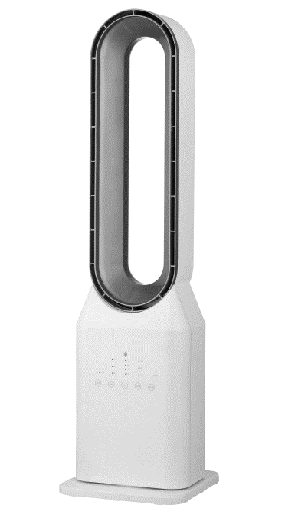
Base
Control Panel
Body
Outlet

OPERATION

Your fan may be operated by using either the manual controls located on the front of the fan or by your remote control.

CONTROL PANEL AND SETTINGS

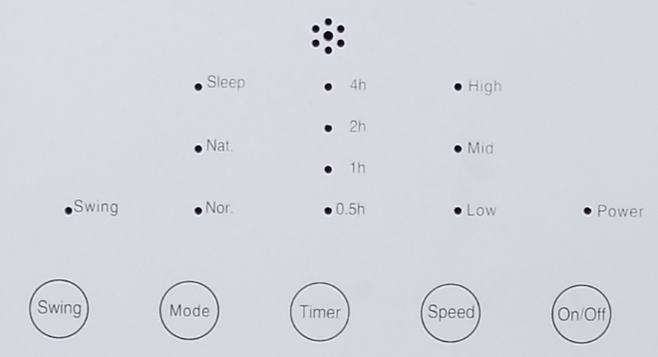

- POWER Button
Used to turn the fan on and off.

- SPEED Button
On start up, press to select the desired wind speed.

- SWING Button
Press to start the swing function. The button light will turn on. Press the button again to turn of the swing function.

- TIMER Button
Press to start the timer function. Each press will increase the timer by 0.5 hours. The timer function can be set between 0.5 and 7.5 hours.

- MODE Button
Press to alternate between natural wind and sleep wind.

REMOTE CONTROL

Your bladeless fan is supplied with a remote, which allows full control of all the units functions. The Buttons on the remote have the same effect as the buttons on the main control panel.

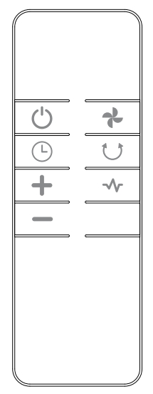
Mode
Swing
Speed
Timer Adjust key
Timer
Power

REPLACING THE BATTERIES
The remote control is powered by 2 x AAA Batteries. To replace:
1. Turn the remote over and remove the back cover.
2. Remove the depleted batteries.
3. Replace the batteries with the same type. Ensure the orientation is correct to the markings inside the battery compartment.

MAINTENANCE CLEANING AND STORAGE
ATTENTION: Please shut off the unit and unplug from the mains before cleaning or performing any maintenance.
Cleaning the surface
Clean the fan with a duster or a soft wet cloth.
Do not use chemical solvents (such as benzene, alcohol, or gasoline) as they may cause irreversible damage. Make sure no water enters the control panel or fan motor
Do not run the unit until completely dry.
Place the fan in its original box or cover the fan to protect it from dust.
Store it in a cool dry place.

TROUBLESHOOTING
Do not repair or disassemble the unit by yourself, unauthorized repair attempts will invalidate the warranty and may cause bodily harm.
Issue | Possible Reason | Solution
No power | 1. Power cord is unconnected  2. There is no power from socket  3. The power switch is not on. | 1. Connect the power cord  2. Check socket is turned on  3. Turn the unit on
Odour emission from unit | 1. New unit. When the unit is used for the first time the fan motor may produce and odour which will dissipate within a week of use | 1. No action required
Strong vibrations and noise | 1. Fan is not used on a flat surface  2. Fan may be damaged | 1. Place on a flat surface. May put an anti-vibration mat underneath  2. If fan is damaged discontinue use and contact service centre.

If the above solutions do not resolve the problem please contact the service centre.
APPENDIX

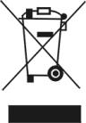
Disposal: Do not dispose this product as unsorted municipal waste. Collection of such waste must be handled separately as special treatment is necessary.
Recycling facilities are now available for all customers at which you can deposit your old electrical products. Customers will be able to take any old electrical equipment to participating civic amenity sites run by their local councils. Please remember that this equipment will be further handled during the recycling process, so please be considerate when depositing your equipment. Please contact the local council for details of your local household waste recycling centres.

TECHNICAL DATA
Model | HBFW
Fan Speeds | 3
Cable length | 1.5 meters
Rated Input | 50 Watt
Fan Speed (r/min) | 1200
Air Volume | 50 m3/hr
Power Supply | 220-240V/50Hz-60Hz
Net Weight | 5 kg
Dimensions | 235*235*900MM

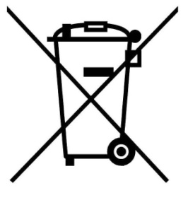
RECYCLING
For further information, please contact your local or regional authorities.
Electronic products not included in the selective sorting process are potentially dangerous for the environment and human health due to the presence of hazardous substances.

CUSTOMER SERVICE
Australian Customer Service

GAF Control (Sales) Pty Ltd
P.O Box 19
Altona North Victoria 3025
Phone: 1300 659 489
Hours: 9am-5pm (EST) Mon-Fri
www.gafcontrol.com.au
*This product may vary slightly to the product illustrated due to ongoing product development.

